The website [thebigbelltest.org](https://thebigbelltest.org/)

Done by Marianna  
1.There is a whole scientific community interested in providing an indisputable proof that nature violates Bell's inequality. Explain why the Big Bell Test assures that they closed all the loopholes and what does it imply for our understanding of the universe.

In 2016 thousands of human volunteers, known as Bellsters, invested their time to take part in the BIG Bell test. They chose measurements to prove that the particles are not influenced in the choice of measurement and hence it closed the so called “freedom-of-choice loophole”. This term was firstly introduced in Scheidi in order to show that the hidden variable can have their influence on choices. The definition of the latter was the following: “the possibility that the settings are not chosen independently from the properties of the particle pair.”

If this case wasn’t closed it could have invalidated the whole test, just like letting scholars choose their own questions for the exam. As the physical systems such as rolling a dice and choosing a number, or some random number generator are all made of entangled particles they will not allow the same type of experiments for the freedom-of-choice loophole to be closed. On the other hand, human decisions as well as choices can be done independently of the particles.

As about 100 thousand people took part in the BIG Bell experiment, it generated nearly 90 million bits. In fact, this huge number of bits were enough to make the outcome of the test trustworthy enough.

As we found out during our research Einstein considered the idea about quantum entanglement as problematic and called it as “spooky action at a distance”. Also, he suggested that this phenomenon was not possible and is most probably because of the hidden signals and as he called them “instructions” in particles. This is an argument about two fundamental principles, which are locality and realism. The first term, locality, suggests that objects can be influenced only by causes from their surroundings. While, realism claims that the properties in the universe are all well-defined and the existence of the properties doesn’t depend on us. These two principles are known as “local realism”. So, while this seems to be a natural thing for us, it happens to be that quantum mechanics contradicts these principles. Hence, quantum mechanics shows that observing particles can change their properties. Therefore, this changes the way we understand and believe that the universe worked.

Done by Satenik

**2:** Gamification is a powerful tool that can be used in several contexts, such as marketing and generation of products. Explain how The Big Bell Test experiment utilized gamification for generating random numbers and imagine and discuss other possible applications of gamification in quantum computing.  
  
The BIG Bell test works the following way: The people who want to take part in the experiment send their bits through the website. In this test specifically, there are only two completely different ways that someone can participate. The first option is by sending 0-s and 1-s through the simple interface, while the second option is through gaming. All the generated bits will be sent to the experiments in order to do the measurements. As a result, the organizers of the experiment know that the human generated bits are unique and are the outcome of the conscious decision process.

It is notable that the research institute, ICFO, used a cloud server and gained human-generated bits from all around the world for the experiment. As the researchers Hugues de Riedmatten and Carlos Abellan from ICFO stated, modern technology is what made this experiment possible. However later as Morgan Mitchell mentioned, machines nowadays cannot fully give answers about the local realism and that every one of us should be participating in this experiment, in order “to keep the Universe honest.”  
  
Even before the BIG Bell test Futurism published an article called “Help Build Quantum Computers by Playing Video Games.” In the article, there is an example of a game called Quantum Moves. The results of the following game were shocking as there were a number of players who managed to outperform not only the usual computers but also they were able to beat the limit of the quantum speed. As Sabrina Maniscalco, a quantum physicist from Finland stated in the article “Being able to successfully gamify problems in quantum physics is a novel and potentially very powerful way to channel human brain power to advance research, and could have incredible implications for the development of quantum technologies such as quantum computers.”

Done by Marianna  
3. Choose two of the thirteen nodes of the Big Bell Test experiment and compare their physical system, degree of freedom measured, rate of bits consumed and total number of bits, how where the bits used, how long the experiment took, and the distance between Alice and Bob.

The whole BIG Bell test consisted of overall 13 BIG Bell test experiments, which included some realism tests and ture Bell tests that required the ability to choose freely the measurement. In the table below it is shortly presented all the major factors of all the experiments. 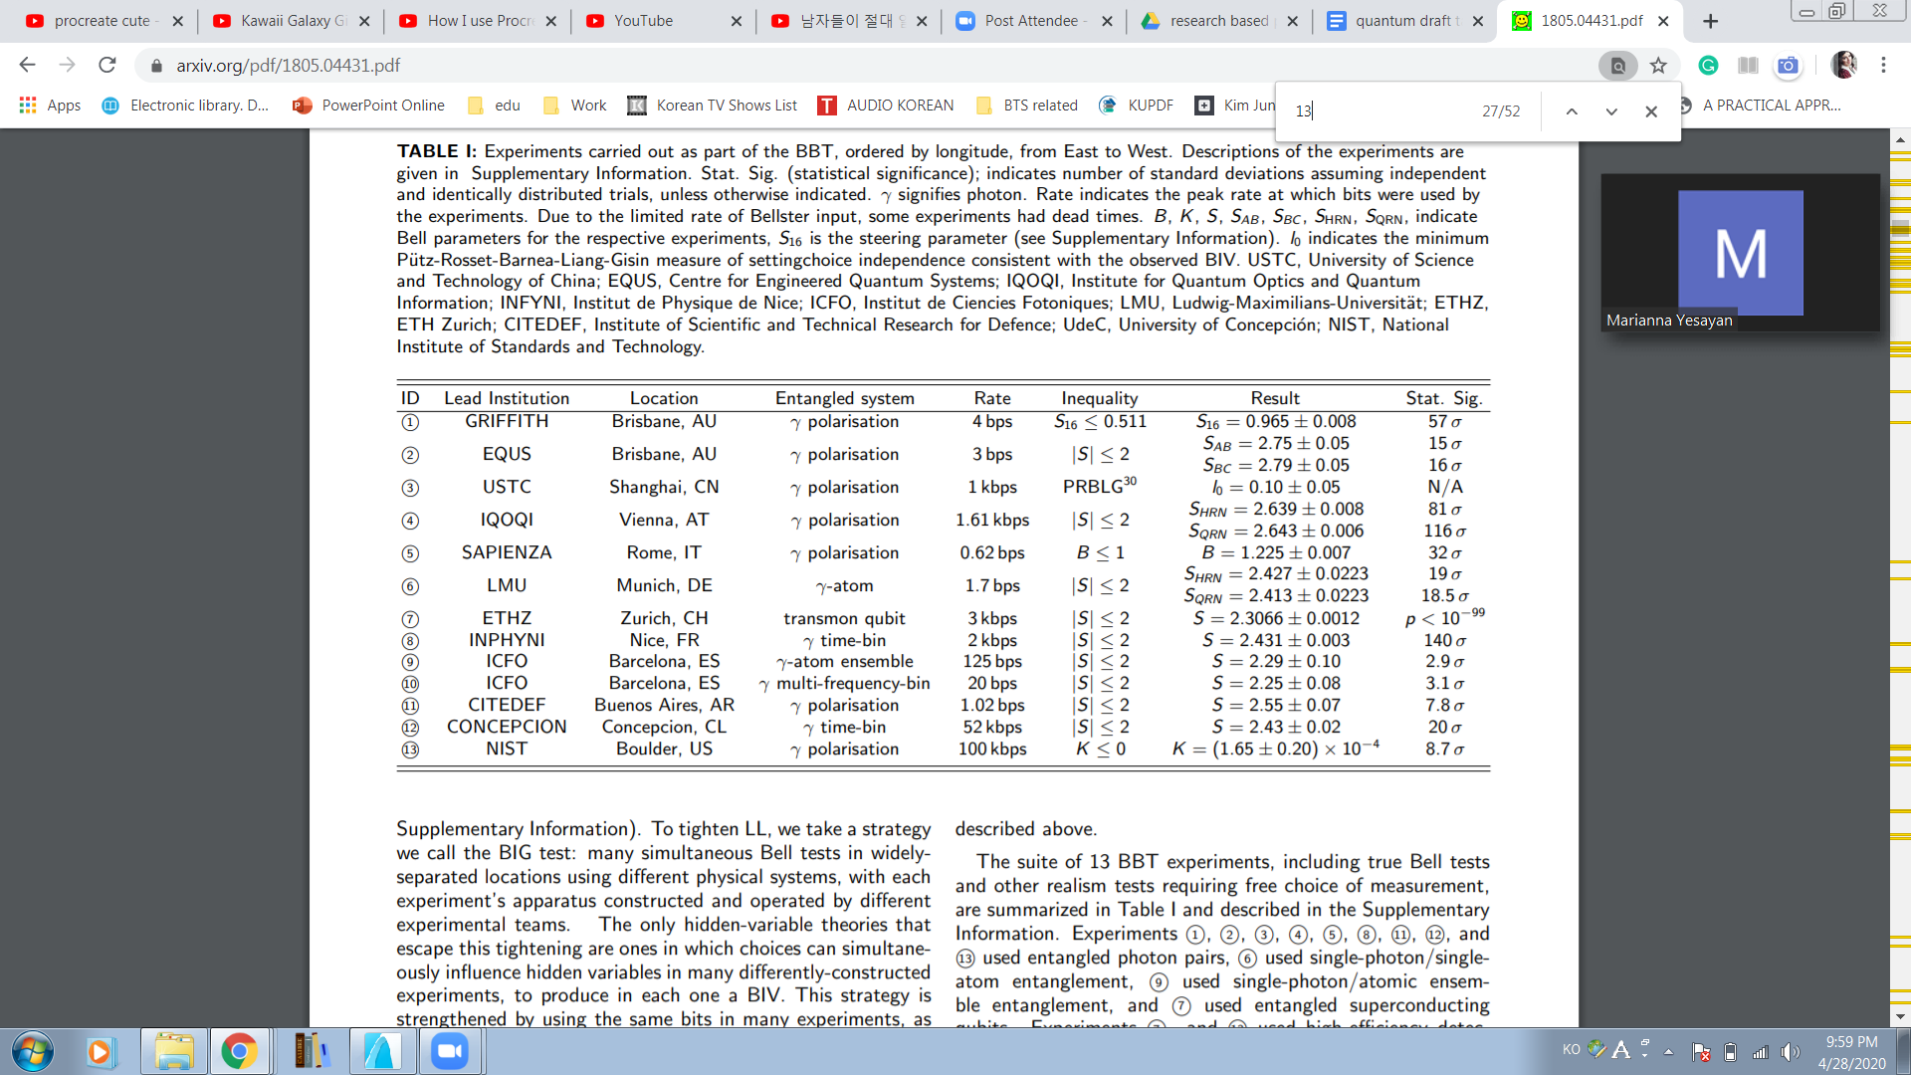   
  
As we can see from the table only the experiments numbered 1, 2, 3, 4, 5, 8, 11, 12, and 13 used entangled photon pairs. Whereas, 6th used single-photon / single-atom entanglement, the 7th used entangled superconducting qubits and finally the 9th used single-photon/atomic ensemble entanglement. So, the 7th experiment alongside with the 13th in order to avoid the fair sampling assumption used high-efficiency detection. The latter one also prevents from having freedom-of-choice loopholes and simultaneously closes the detection efficiency. The analysis of the 1st one claimed quantum steering, while the 2nd one demonstrated a three-station measurement with temporal quantum correlations. Furthermore, we see that the 5th experiment tested a violation of bi-local realism. On the other hand, the 10th experiment contravened a well known Bell inequality for multi mode entanglement. Based on energy-time entanglement the 12th BIG Bell test closed the post-selection loophole typically. Accordingly, the deep analysis of the 3rd experiment shown puts bounds about how well the local model that was measurement-dependent could have been able to tell beforehand the behavior of a Bellster in order to have the desirable and observed results. Whether or not the human generated measurement and the machine generated choices were different from each other was tested via 3rd, 4th, 6th and the 13th experiments.

Let’s take the 3rd and the 7th experiments and compare them. The entanglement system is different as the 3rd one has gamma polarisation while the 7th has a transmon qubit system. Accordingly, the rates of bits are 1 kbps for the 3rd one and 3kbps for the 7th one.

In the experimental setup shown below for the Big Bell test red and dashed lines represent free-space beams and electrical connections. And the propagation distance between Bob to source is 45 m and from the source to Alice - 15 m.

